15 Minute Garden Pasta
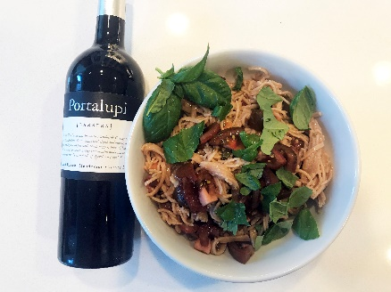

Ingredients: 1 pound spaghetti pasta (Italian dry or we like to make our own)
From the Garden: 2 large tomatoes diced, 1/2 cup fresh basil, 2 cloves garlic minced, 1/4 cup extra virgin olive oil, 1/4 teaspoon salt to taste, 1/4 teaspoon black pepper
Instructions:
Pasta: We love making our own pasta. We purchased the Phillips pasta making machine and it has been the best kitchen appliance ever. Combine 2 cups of wheat flour and 1 cup Semolina. Mix 1 egg and slightly less than 1 cup of water. For this dish, we use the spaghetti attachment. After drying pasta for 1/2 hour, place in boiling water for 4-6 minutes. Or you can boil dried pasta from Italy for 8 minutes.

Prepare the sauce. Chop fresh tomatoes from the garden, cut basil leaves, mince garlic, and combine with live oil in a large bowl.

Drain the pasta and add it into the large bowl. Stir to combine and add salt and pepper to taste. Toss and serve hot or cold.

Pour yourself a glass of Arneis or Barbera!

