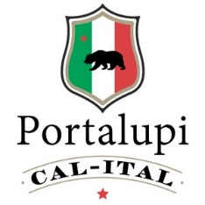
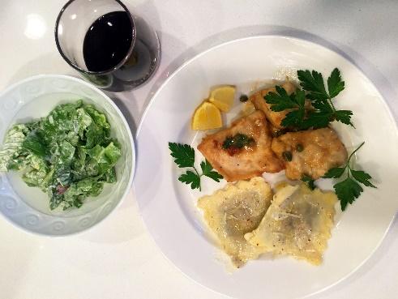

Chicken Piccata
Ingredients: 2 skinless and boneless chicken breasts
Sea salt and fresh ground pepper
All-purpose flour for dredging
6 tablespoons unsalted butter
5 tablespoons extra virgin olive oil
2 lemons for fresh lemon juice
½ cup organic chicken stock
½ cup Portalupi Arneis
¼ cup capers, rinsed
1/3 cup fresh parsley

Directions: Season chicken with salt and pepper. Dredge chicken in flour and shake off excess. In a large skillet over medium high heat, melt 2 tablespoons of butter with 3 tablespoons olive oil. Add 2 pieces of chicken and brown chicken on both sides for 3 minutes.

Remove chicken and transfer to a plate. Melt 2 more tablespoons butter and add another 2 tablespoons olive oil. Add lemon juice to pan, chicken stock and capers, ½ cup Portalupi Arneis. Stir over medium heat and bring to boil, then turn to simmer. Return chicken to pan and warm for 5 minutes. Remove chicken (again) and plate. Add remaining butter and stir then pour sauce over chicken and garnish with parsley.

