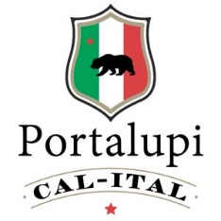
Garden Caesar Salad
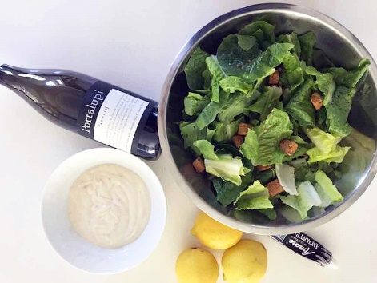

Makes 1/1/2 cups.
Ingredients: 2 small garlic cloves, minced, 1 teaspoon anchovy paste, 2 tablespoons freshly squeezed lemon juice, 1 teaspoon Dijon mustard, 1 teaspoon Worcestershire sauce, 1 cup good quality mayonnaise, ½ cup freshly grated Parmigiano-Reggiano, ¼ teaspoon salt, ¼ teaspoon freshly ground black pepper
Instructions: In a medium bowl whisk together the garlic, anchovy paste, lemon juice, mustard and Worcestershire sauce. Add the mayonnaise, Parmesan, salt, and pepper, then whisk dressing until well combined. Taste and adjust to your liking. Toss the dressing with romaine lettuce, croutons, and more grated Parmesan.
Grab fresh lettuce from your garden. Add your favorite croutons and dressing. I sometimes chop some anchovies because I love them so much.

