In Vino Pesto Ravioli

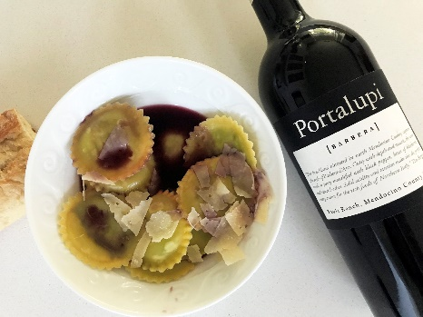

Ingredients: 1 9 ounce fresh 3 cheese ravioli. For Pesto: 1 1/3 cups fresh spinach, 2/3 cup fresh basil leaves, ¼ teaspoon crushed red pepper, 2 garlic cloves, 2 tablespoons chicken broth, 2 tablespoons olive oil, 1 tablespoon fresh lemon juice. 1 plum tomato, sliced. Garnish: ½ cup shaved, fresh Parmesan cheese, 1/3 cup pine nuts, toasted

Directions: Cook ravioli to package directions, drain and set aside. Combine spinach, basil, salt, red pepper, and garlic in food processor. With processor running, add broth, olive oil and lemon juice until mixture is smooth.
Combine ravioli, pesto, and sliced plum tomato in medium saucepan over medium heat to warm through, just a couple of minutes. Garnish with toasted pine nuts and Parmesan cheese.

The Finale: In your favorite pasta place in bowl and pour Portalupi Barbera over the dish. It is amazing!

