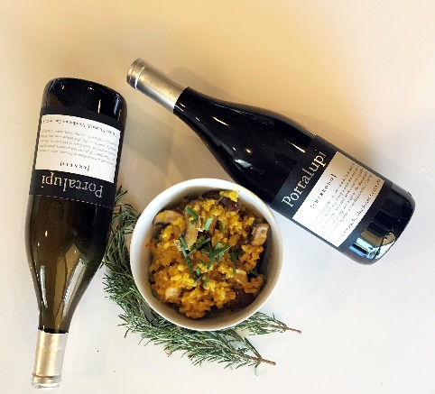

Mushroom and Saffron Risotto

Ingredients: 6 cups vegetable broth, 3 tablespoons olive oil, 1 pound portobello mushrooms, thinly sliced, 1 pound Chef mushrooms, thinly sliced, 2 shallots, diced, 1 1/2 cups Arborio rice, 1/2 cup Portalupi Arneis, sea salt to taste, freshly ground black pepper to taste, ½ teaspoon Saffron, 2 tablespoons fresh rosemary, 3 tablespoons finely chopped chives, 4 tablespoons butter, 1/3 cup freshly grated Parmesan cheese

Directions: In a saucepan, warm the broth over low heat. Add Saffron to broth.
Warm 2 tablespoons olive oil in a large saucepan over medium-high heat. Stir in the mushrooms and rosemary and sauté 5 minutes. Remove mushrooms and their liquid, set aside.
Add 1 tablespoon olive oil to skillet and stir in shallots. Cook 1 minute. Add rice, stirring to coat with oil, about 2 minutes. When the rice has taken on a pale, golden color, pour in wine, stirring constantly until the wine is fully absorbed. This is the most important step in making Risotto-patiently adding the broth. Add 1/2 cup broth to the rice and stir until the broth is absorbed. Continue adding broth 1/2 cup at a time, stirring continuously, until the liquid is absorbed, and the rice is al dente, about 15 to 20 minutes.
Remove from heat, and stir in mushrooms with their liquid, butter, chives, and parmesan. Season with salt and pepper to taste.

