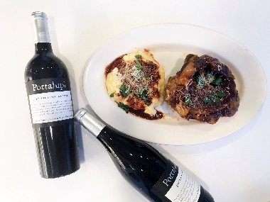
Osso Buco
Ingredients: 1 sprig fresh rosemary and 1 sprig fresh thyme, 3 dry bay leaves, 2 whole cloves, cheesecloth, kitchen twine, to wrap herbs and tie the beef shanks, 3 whole beef shanks (about 1 pound per shank), trimmed, sea salt and freshly ground black pepper, all-purpose flour, 1/2 cup vegetable oil. Vegetables: 1 small onion, 1 small carrot, 1 stalk celery, (all vegetables diced into ½ inch pieces) 1/2 cup tomato paste, 1 cup dry white wine, Portalupi Arneis, 3 cups chicken stock, 3 tablespoons fresh flat-leaf Italian parsley, chopped, 1 tablespoon lemon zest

Directions: Place the rosemary, thyme, bay leaves and garlic cloves into cheesecloth and secure with twine. For the beef shanks, pat dry with paper towels to remove any excess moisture. Secure the meat to the bone with the kitchen twine. Season each shank with salt and freshly ground pepper. Dredge the shanks in flour, shaking off excess.

In a large Dutch oven pot, heat vegetable oil until smoking. Add tied beef shanks to the hot pan and brown all sides, about 3 minutes per side. Remove browned shanks and reserve.
In the same pot, add the diced onion, carrot, and celery. Season with salt. Sauté until soft and translucent, about 8 minutes. Add 1 Tablespoon of the tomato paste and mix well. Return browned shanks to the pan and add the (Arneis) white wine, reduce liquid by half, about 5 minutes. Add the wrapped herbs and 2 cups of the chicken stock and bring to a boil. Use the rest of the tomato paste and smooth over shanks. Set oven at 210 degrees, (low and slow) Cover Dutch oven roasting pan and cook for 3-4 hours or until the meat is falling off the bone. Check and add more chicken stock or wine, as necessary. The level of cooking liquid should always be about 3/4 the way up the shank.
Carefully remove the cooked shanks from the pot and place in decorative serving platter. Cut off the kitchen twine and discard.
Remove wrapped herbs. Pour all the juices and sauce from the pot over the shanks. Garnish with chopped parsley and lemon zest.

