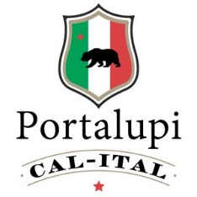
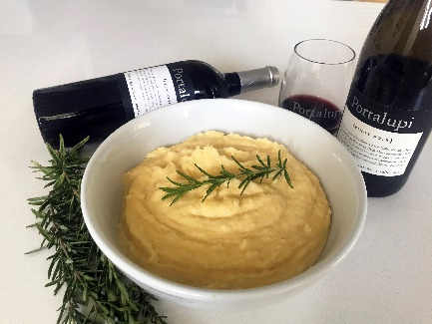

Polenta with Mascarpone

Ingredients: 6 Tablespoons unsalted butter, ½ small onion, 1 clove garlic, minced, 4 cups Chicken stock, 2 cups polenta, ¼ cup mascarpone cheese, ½ cup grated parmesan cheese, Kosher salt, and freshly ground pepper

Melt 2 Tablespoons butter in large saucepan over medium heat. Add the onion and garlic and cook until the onion is translucent, about 5 minutes. Add the chicken stock and bring to a simmer. Slowly whisk in the polenta. Reduce the heat to low and cook, stirring frequently, until the polenta is thick. Adjust consistency with half and half. Remover from the heat and whisk in the mascarpone, parmesan, and the remaining 4 Tablespoons butter. Season with salt and pepper and garnish with parsley.
!

