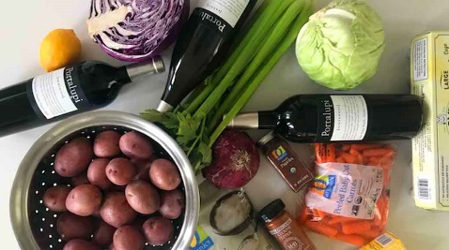

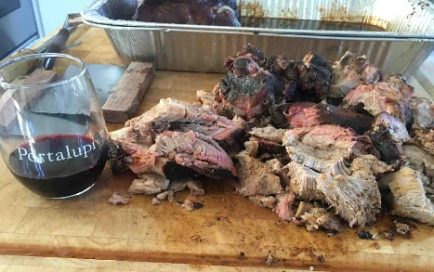

PULLED PORK SLIDERS:

Ingredients: Two 4 lb. Pork Shoulder (Bone In), 1 cup Root Beer, Slider buns

Directions:
Day 1:
Prepping the meat. With a liquid food injector, inject into 3 to 4 locations of the top (Fat Cap of Pork shoulder facing top of the meat) ½ to 1 cup of Root Beer,. Rub by hand the top, sides with your Rub. You can use McCormick’s/Lawry’s Memphis BBQ rub or our recipe. Place in large aluminum roasting pan both shoulders, keep the fat cap up. Cover with foil and refrigerate for at least 24 hours.

At the same time, get your wood or wood chips. Soak in plastic food grade 5-10-gallon container/bucket. Use 2-3 gallons of water and ½ to 1 gallon of apple juice. The wood/wood chips will also soak for 24 hours. Need enough wood to last 3 to 6 hours on low coals. Ideal smokehouse temperature will be between 180 to 210 degrees. Best with Oak or Applewood (avoid hickory or mesquite) DAY 2:

Early morning: Take the meat out of the frig and let stand on kitchen counter with cover for 2-3 hours to get to room temperature. After an hour of meat sitting on counter, it is time to start your fire with some kindling and briquets and/or your oak/apple firewood. Take your firewood/chips out of the soaking bucket and allow to drain for at least an hour. Once coals are not burning but glowing, put meat into smoker and place a sizable amount of soaked wood on coals. Close smoker and sit back and have a brew. Check your wood in the firebox periodically to make sure you have continuous smoke and add wood as needed.

After approximately 3-4 hours your pork should have a deep brown, almost black crust formed. Remove and return to roasting pan, keeping fat cap up. Place in 200-degree oven covered with foil for 3 hours.

Take meat out and place on butcher block and let rest for 1 hour. Remove from pan and trim fat cap with butcher knife. Use butcher knife or meat cleaver to remove shoulder blade bone (should fall off the roast quite easy. Then start pulling the meat apart by hand and chopping with cleaver. When all the meat has been pulled and chopped, place back in roasting pan with juice drippings, toss, cover with foil and return to oven on warm setting.

Serve on slider buns (We LOVE Costeaux’s potato buns) top with BBQ sauce, scoop of coleslaw. RECIPES: Rub Recipe: Mix together: ¼ cup brown sugar, ¼ cup sugar, ½ cup paprika, 1/3 cup garlic powder, 2 tsp salt, 1 teaspoon chili powder, 1 tsp cayenne, 2 teaspoons black pepper, 1 teaspoon dried oregano and 1 teaspoon cumin.

Carolina Pulled Pork, BBQ Sauce: Mix: ½ cup mustard, ½ cup balsamic, 2 Tablespoons Butter, 1 Tablespoon Worchester, 1 Tablespoon Lemon, 1 tsp Cayenne. Mix and cook for 30 minutes on stovetop.

Red Potato Salad: 2 pounds red new potatoes (scrubbed, cut in chunks) , 5 hardboiled eggs, 1 cup mayonnaise, ½ lemon, squeezed, 1 ½ tablespoons Dijon mustard, ½ cup chopped red onions, ½ cup sweet relish, 1/3 cup celery, 1 teaspoon Creole seasoning, salt and pepper to taste, top with 2 Tablespoons Herbs (Parsley)

Bring a pot of salted water to boil. Add potatoes, cover, and cook until tender but firm about 8-10 minutes. Drain and let cool in a separate bowl. Chop boiled eggs, add to potatoes, red onions, and celery. Combine mayonnaise, relish Cajun spice, mustard, lemon juice and mayonnaise. Mix well, add to the potato, onion, celery, herb and egg mixture. Adjust salt, pepper, and creole seasoning. Refrigerate till ready to eat.

Coleslaw: Dressing: Combine, 1/2 cup mayonnaise, 1 tablespoon white vinegar, 1/2 tablespoon cider vinegar 2 teaspoons sugar ½ teaspoon celery seeds salt & pepper to taste.

Toss with 3 cups green cabbage finely shredded, 2 cups purple cabbage finely shredded and 1 cup carrot finely shredded Refrigerate at least 1 hour or even up to 3 days before serving to allow flavors to blend.

