Fresh Strawberry Gelato
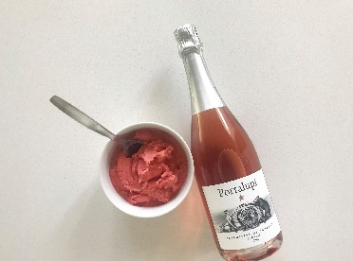

Ingredients: 1-pound fresh strawberries, 1 cup granulated sugar, 3/4 cup water,

2 tablespoons freshly squeezed lemon juice, 1/2 cup heavy whipping cream

Instructions: Remove the stems and leaves from the strawberries and rinse in cold water. Place the strawberries, lemon juice and the sugar in a food processor and process until liquefied. Add the water and run the food processor until all the mixture is smooth. Whip the cream with a wire whisk until it begins to thicken slightly and becomes the consistency of buttermilk. Mix the cream and strawberry mixture in a bowl and mix thoroughly. Pour the mixture into an ice cream maker and freeze following the manufacturer’s instructions.

