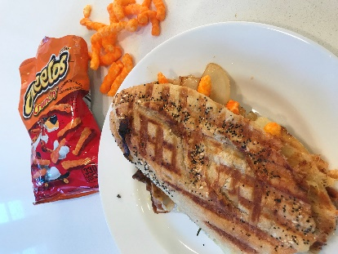

Toasted Cheese Panini with Cheetos!

Ingredients: 2 slices Sourdough bread, 4 to 6 thin slices Gouda, Havarti, Swiss or Provolone cheese, 1 cup crunchy Cheetos,1 handful baby arugula, Melted unsalted butter for brushing

Instructions: Turn on your Panini maker. Butter the outside of 2 slices of Sourdough French Bread. Place 2 or 3 slices of Gouda, Havarti, Swiss or Provolone (or mix them up) cheese on each side of the bread. Once the cheeses are melted and bread toasted, pile on the Cheetos and baby arugula, then close the sandwich. Eat IMMEDIATELY before the Cheetos get soft.
Pour yourself a glass of Vaso di Marina!

