Seriously Smokin’ Turkey
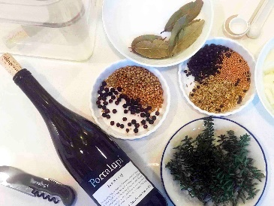
Brine Ingredients: 7 quarts of filtered water, 1 ½ cups Kosher salt, 6 bay leaves, 2 Tablespoons whole coriander seeds, 1 Tablespoon dried juniper berries, 2 Tablespoons whole black peppercorns, 1 Tablespoon fennel seeds, 1 teaspoon mustard seeds, 1 18-20 pound thoughtfully raised and harvested Turkey, 1 bottle Portalupi Arneis, 2 chopped medium onions, 6 crushed garlic cloves, 1 bunch fresh thyme.
(Think about the timing of your meal, including 24 hours for brining and approximately 6-8 hours from setting turkey, smoking, roasting to carving)
Instructions: Combine all of the spices and heat for 5 minutes (mostly to dissolve the Kosher salt) then pour into a large enough food safe, sanitized bucket to brine the turkey. Add onion and garlic. Stir mixture, place turkey butt down and refrigerate for 24 hours. Flip turkey once during the 24 hours and weight turkey if not submerged.

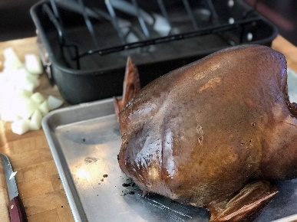

Seriously Smokin’ Turkey!
Instructions: Pull turkey out of brine, drain in sink. Pat dry with paper towels and let stand for 1-2 hours to come close to room temperature. After brining for 24 hours the smoking of the turkey will infuse the flavors.
Getting the Smoker ready: We recommend using wood or chips such as apple or oak. The goal is to get your wood so it will hold the temperature to around 200 degrees for 2 to 2 ½ hours. The intent is not to roast the turkey but to induce flavor and finish cooking in your oven. Preheat oven to 350 degrees, Remove turkey from smoker. Stuffing is optional-now is the time to stuff your turkey with stuffing if you choose to. Tent the turkey with foil to avoid over crisping the skin while roasting in the over. and place in preheated oven for 2 hours or when the thickest center portion of thigh reaches 165 degrees on a probe thermometer. Once out of the oven, let turkey rest for 45 minutes and carve.

