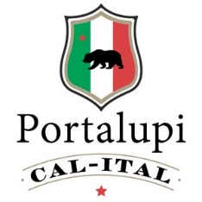
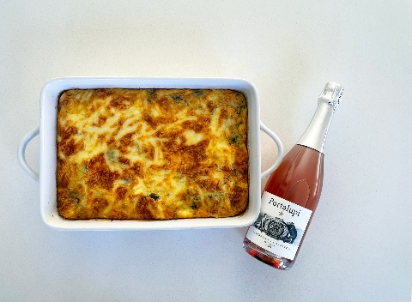
Italian Pancetta Strata
Ingredients: 1/3 pound pancetta, chopped, 4 tablespoons butter, 1 medium sweet onion chopped, 2 cups fresh mushrooms, 3 cups spinach, chopped, 10 large eggs, 1 cup heavy whipping cream, ½ teaspoon salt and ½ teaspoon fresh ground pepper, 8 ounces mascarpone cheese, 1 cup shredded mozzarella cheese, ½ cup shredded Asiago cheese (1 cup Apricot preserves, optional) 3 tablespoons chopped fresh basil.
Directions: In a large skillet, sauté pancetta until crisp, stirring. May need to add a little butter to pan. Remove with slotted spoon and keep drippings in pan. Add 1 tablespoon butter and heat. Add onion, cook until tender about 6 minutes. Transfer onion to bowl.
Add rest of the butter and saute mushrooms, cook 3 minutes and then add spinach and cook for a minute. Mix together pancetta, mushrooms, spinach, onions together in a bowl and add to a greased 13 by 9 inch pan.
Beat the eggs, cream, salt and pepper until blended. Beat in mascarpone cheese and blend. Pour into 13 by 9 inch pan and top with mozzarella and Asiago cheese. (If you want the Apricot preserves, you would add on top)
Bake for 40 minutes. Let sit about 5 minutes before serving to set.

