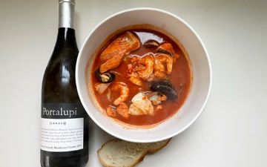
Cioppino!

Ingredients: 3 Tablespoons olive oil, 1 large fennel bulb thinly sliced, 1 onion chopped, 3 large shallots chopped, 2 teaspoon salt, 4 large garlic cloves, finely chopped, ¾ teaspoon crushed red pepper flakes, ¼ cup tomato paste, 1 28 ounce can diced tomatoes with juice, 1 ½ cups Portalupi Arneis, 5 cups fish stock, 1 bay leaf, 1 pound clams, scrubbed, 1 pound mussels, debearded, 1 pound uncooked shrimp, peeled and deveined, ¾ pound halibut and ¾ pound salmon (no skin)

Directions: Heat the oil in a very large pot over medium heat. Add the fennel, onion and shallots, salt and sauté about 10 minutes. Add garlic and red pepper flakes and sauté 2 minutes. Stir in the tomato paste, tomatoes with juices, wine, fish stock and bay leaf. Cover and bring to simmer for about 30 minutes.

Add clams and mussels to liquid. Cover and cook until they open about 5 minutes. Add shrimp and fish. Simmer gently until just cooked, about 5-8 minutes. Season with more salt and red pepper flakes to your taste.

Pour yourself a glass of Arneis.
:

