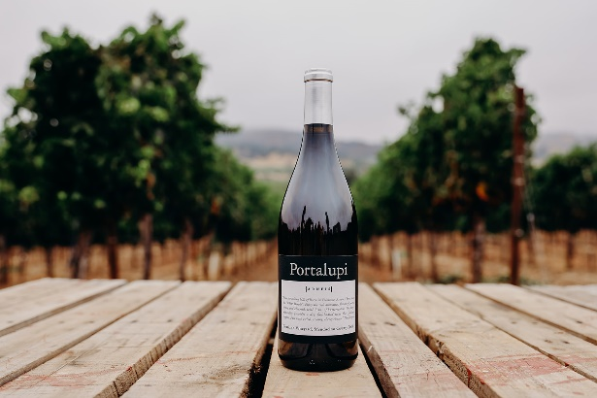

2020 Arneis, Graziano, Graziano Family Vineyard, Mendocino County
Our grapes are from the Potter Valley region of Mendocino County. The Graziano family celebrated 100 years and is one of the oldest grape growing families in Mendocino County. The subsoil of Potter Valley is made of Franciscan bedrock. This layer is covered by alluvial silts and clays with more gravel and sandstone. The Arneis is a tricky grape to grow (Arneis means “a difficult and demanding person in Piemontese), Originally from the rolling hills of Roero in Piemonte, Arneis is known as the “White Barolo”. Enjoy Aromas of peaches, green apple and nutmeg. Flavors of vanilla, dried stone fruits and spring rain’s shale peach, gardinia. Brilliantly balanced and wanting for scallops and lobster ravioli.
Appellation: Mendocino County Vineyard: Graziano Vineyard Harvest: October 22, 2020 4.8 tons 24 brix Winemaking: 5 months in Stainless Steel Tank Cases: 300 Alcohol: 14%
Awards: 90 Points Wine Enthusiast
Double Gold SF Chronicle Wine Competition

Portalupi 107 North Street Healdsburg, CA 95448 www.portalupiwine.com 707.395.0960
Facebook, Instagram: PortalupiWine

