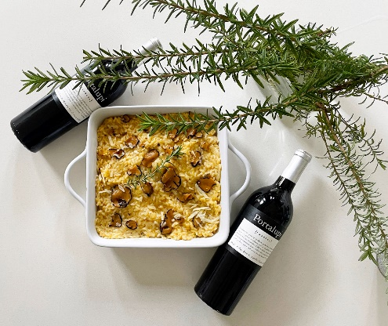
Acquerello Risotto with Black Truffle
The key to a traditional Piemonte risotto is to use Acquerello rice. Chefs use this highly versatile strain all over Italy as the extra-long ageing process straightens the grain, making it less likely to break down in cooking.
Serves four.
Ingredients: 6-8 cups vegetable broth, 4 Tablespoon extra-virgin olive oil, 2 cups yellow onion chopped, 1 teaspoon salt, 2 cups Acquerello rice, 2 Tablespoons unsalted butter, 1 cup Portalupi Arneis, ½ cup Grana Padano, finely grated, Garnish with TruffleHunter black slices on top.

Directions: Heat the broth to boil. Cover and keep hot. Use a separate pan for the Risotto. Add olive oil, onion, and salt, medium heat. Cook about 8 minutes. Add the rice and stir constantly, toast but do not brown. Pour in the wine and keep stirring for another couple of minutes until rice is dry. Ladle in 2 cups of the simmering broth to cover the rice, decrease the heat. Cook, stirring steadily until totally absorbed. Ladle in more broth to cover the rice and add another ½ teaspoon salt. Keep stirring as the rice swells and becomes thicker and creamier. When the broth is completely absorbed, ladle in another cup or so of broth. After incorporating 6 cups (or a bit more) over about a 20-minute timeframe, taste the rice for texture and seasoning. Add more salt and/or incorporate more hot broth if needed. The risotto is perfectly cooked when it is both al dente and creamy. Once done, turn off the heat and immediately drop the butter pieces into the saucepan. Stir vigorously to mix the risotto with the butter. Stir in the ½ cup of grated Grana Padano. For each serving, spoon a mound of risotto into a warm bowl and place slices of the TruffleHunter on top.
Enjoy with Portalupi Barbera.

