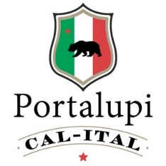

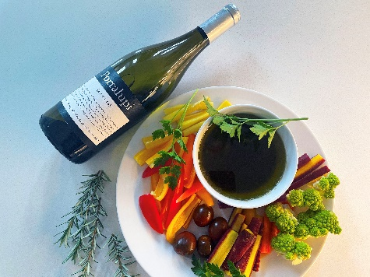

Bagna Cauda Recipe

Ingredients: 6 garlic cloves, ½ cup milk, 1¼ cups olive oil, ½ cup salt packed anchovies, 4 Tablespoons butter
Directions: Night before, peel garlic and infuse in milk overnight. Remove any small bones from anchovies. Next day, remove garlic from the milk and smash with a wooden spoon. Melt the butter in a medium saucepan over low heat and add the garlic cloves, sauté a few minutes. Do not let garlic brown. Add chopped anchovies and the oil, bring to a simmer for 10 minutes until soft. Transfer to a serving dish to keep warm. Serve with a platter of crudities. I love to using all of the seasonal, organic and colorful vegetables. See photo.
Serve with a bottle of Portalupi Arneis.

