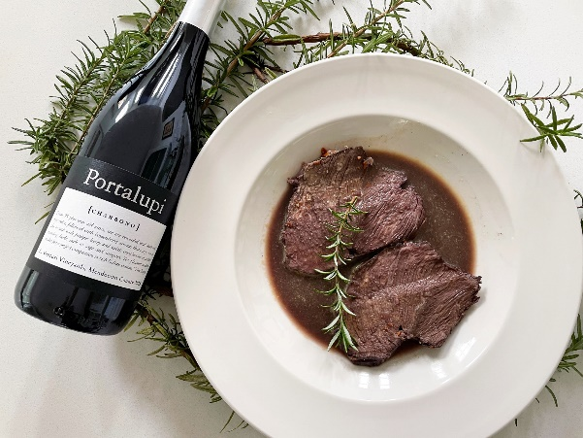
Italian Pot Roast with Charbono (Arrosto al Barolo)
Italian pot roast. The meat is simmered with a heady mixture of vegetables and Portalupi Charbono.

Ingredients: 3.5 pounds Boneless Beef Roast, (purchase grass fed beef and tie roast, 1 clove garlic, 1 medium carrot, 1 onion, 1 stick celery, 2 sprigs rosemary, 1 tsp salt, 1 bottle of Portalupi Charbono

Directions: Dice onion, carrots, garlic, slice celery. Place the beef in a crock pot. Add all the ingredients including the wine. Let cook on medium heat for 2 ½- 3 hours turning 2-3 times. Remove lid for ½ hour to decrease the liquid. Check roast temperature throughout cooking to reach 145 degrees. Remove roast and let it cool, cut into thin slices. Strain wine sauce to remove vegetables. Layer the meat with wine sauce and place in container and then into fridge overnight allowing the flavors of the sauce to sink into the roast. Heat in oven to serve.

Serve with a bottle of Portalupi Charbono.

